Lab53:
Functions in SQL server:
Scalar function:
A scalar function returns a single value based on the input parameters.
Creating a scalar function to calculate the annual salary of an employee.
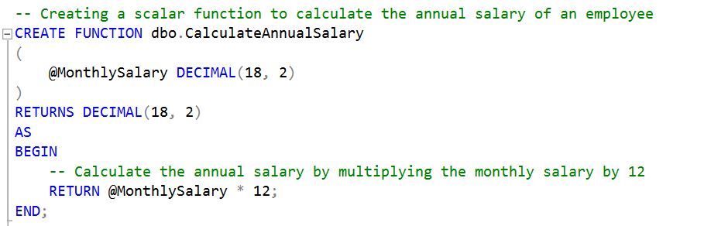

his script creates a scalar function named CalculateAnnualSalary.
The function accepts one input parameter @MonthlySalary of type DECIMAL(18, 2). It calculates the annual salary by multiplying the monthly salary by 12 and returns the result.

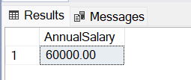

Inline Table-Valued Function:
An inline table-valued function returns a table data type and is defined using a single SELECT statement.
e.g.
Creating an inline table-valued function to get employees with a salary above a certain threshold.
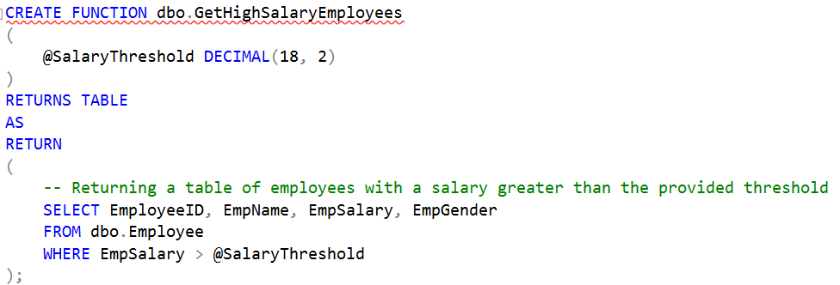

- This script creates an inline table-valued function named GetHighSalaryEmployees.
- The function accepts one input parameter @SalaryThreshold of type DECIMAL(18, 2).
- It returns a table of employees with a salary greater than the provided threshold.

Using the GetHighSalaryEmployees function to get employees with a salary above 50000
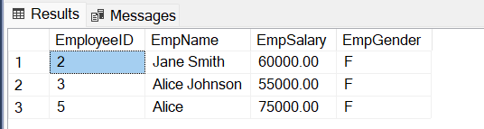

Multi-Statement Table-Valued Function:
A multi-statement table-valued function returns a table data type and allows for multiple statements to populate the table.

e.g.
Creating a multi-statement table-valued function to get employees and their annual salaries.
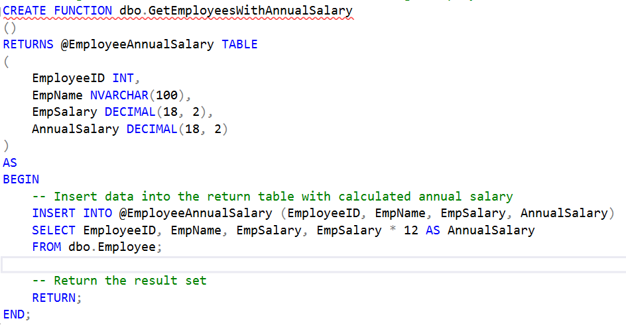
- This script creates a multi-statement table-valued function named GetEmployeesWithAnnualSalary.
- It does not accept any input parameters.
- It returns a table @EmployeeAnnualSalary with columns EmployeeID, EmpName, EmpSalary, and AnnualSalary.
- The function populates the return table by calculating the annual salary for each employee.

Using the GetEmployeesWithAnnualSalary function to get employees and their annual salaries
